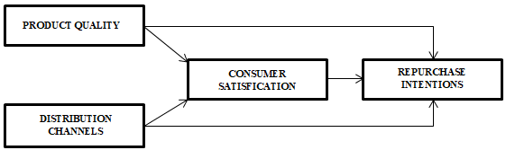
Figure 1. Thinking Framework
Source: primary data processed, 2021

